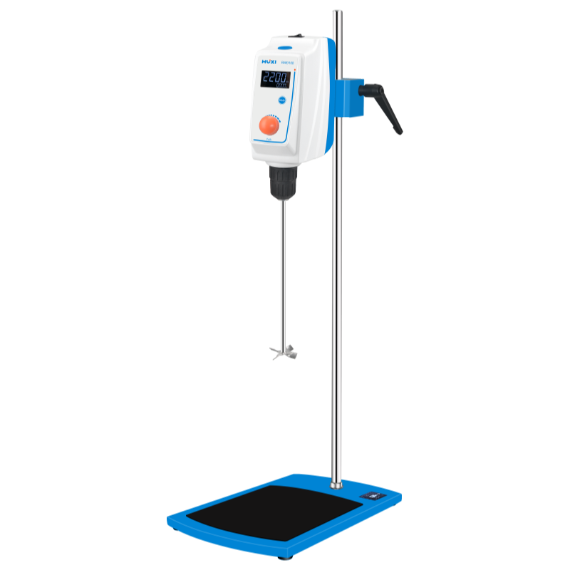

# **RWD200 Overhead Stirrer**

# **Shaker**

# HT-S330 **Rotary Shaker**

**Application：**

RWD200 LCD overhead stirrer use a self-locking collet and independently develops a square lifting and fixing clip. Large LCD display, adjustable speed and time, used for mixing solid-liquid, liquid-liquid or medium and high viscosity samples; mainly used in scientific research, medicine, chemical industry, petrochemical, cosmetics, food, biology and other fields.

**Main Features：**

* LCD screen display, speed and time can be coarsely adjusted, and the working time can also be finely adjusted under the working condition;
* Speed 30-1600rpm, constant speed, high and low speed can be controlled;
* Adopt DC brushless motor, which can run safely for a long time with outstanding performance;
* Overload and motor protection, in case of overload, short circuit or abnormality, it will automatically cut off the circuit and alarm to ensure the safety of the experiment;
* Configuration of stirring paddle penetration holes, users do not need to adjust the installation height of the instrument, only the installation position of the stirring rod;
* The torque can be adjusted automatically according to the viscosity change of the sample, which is convenient for experimental operation;
* A variety of stirring paddles and brackets are available.

**Technical Parameters：**

|  |  |
| --- | --- |
| Model | RWD200 |
| Max. Capacity | 100L |
| Speed Range | 30-1600rpm |
| Speed Display | LCD |
| Speed Accuracy | ±1rpm |
| Speed mode | Coarse and fine adjustment |
| Timing range | 1~9999min |
| Time Display | LCD |
| Max. torque(N.cm) | 100 |
| Max. viscosity (Pas) | 100000 |
| Motor input power (W) | 400 |
| Motor Output power (W) | 200 |
| Protection method | IP42 |
| Motor protection | Display failure and stop automatically |
| Overload protection | Display failure and stop |
| Security | Chuck protective cover, safety buckle, non-slip |
| Allowable ambient temperature (°C) | 5-40 |
| Allowable environmental humidity (%) | 80 |
| Instrument Size | 315*200*780 |
| Main unit package size mm | 475*340*200 |
| Set packing size mm | 803*400*140 |
| Main unit Instrument NW | 6 |
| GW of main unit package kg | 6.5 |
| Set Instrument NW | 9 |
| GW of Set package kg | 13.1 |